Project Design Phase
Solution Architecture

Date | 17 February 2025
Team ID | LVIP2026TMIDSB7385
Project Name | Explore with AI: Custom Itineraries for Your Next Journey
Maximum Marks | 4 Marks

Solution Architecture:
The proposed solution is an AI-powered Travel Itinerary Generator built using Streamlit and Google Gemini Generative AI. The architecture connects the user interface with a generative AI model through secure API integration to automatically create personalized travel plans.
The system follows a simple layered architecture:
- The presentation layer is developed using Streamlit, where users enter destination, days, nights, and interests.
- The application layer processes the inputs and constructs a structured prompt.
- The AI service layer uses the Gemini generative model through API to generate a customized itinerary.
- The response layer sends the generated itinerary back to the Streamlit interface for display.
- This architecture ensures modularity, fast response, and easy future enhancement such as adding hotel APIs, maps, or booking services.
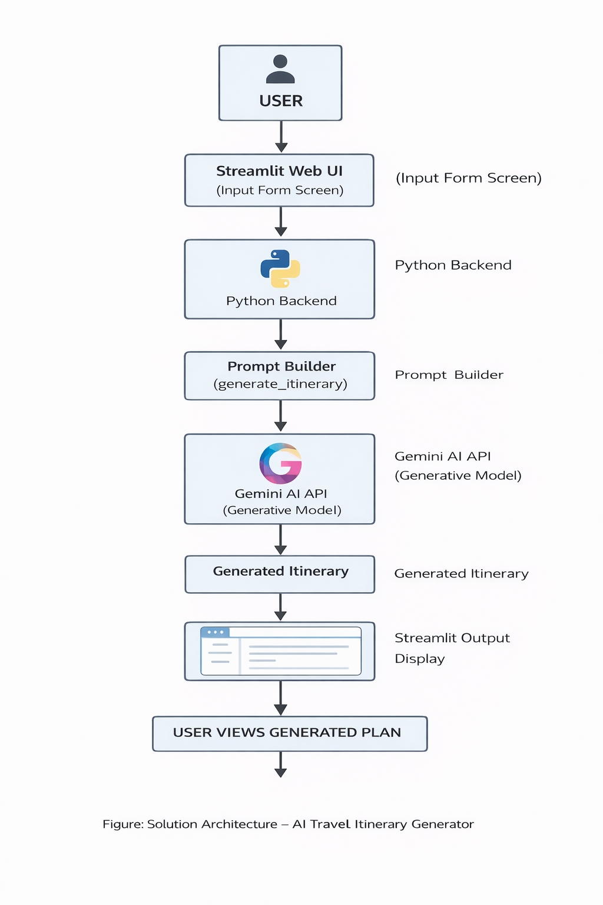
Example - Solution Architecture Diagram

